* MEMBER NAME : W01
  1. General Information

|  |  |  |  |  |
| --- | --- | --- | --- | --- |
| **Design Code** | **Unit System** |  |  |  |
| IS456:2000 | N, mm | 25.00MPa | 415MPa | 415MPa |

* 1. Section & Factor

|  |  |  |  |  |  |
| --- | --- | --- | --- | --- | --- |
| **THK.** | **L** |  |  |  |  |
| 200mm | 1.000m | 1.000 | 3.500m | 1.000 | 3.500m |

* + - * Frame Type : Braced Frame
  1. Force

|  |  |  |  |  |  |
| --- | --- | --- | --- | --- | --- |
|  |  |  |  |  |  |
| 1,111kN | 1,112kN·m | 10.000kN·m | 100.00kN | 0.000kN | 0.00kN·m |

* 1. Rebar

|  |  |  |  |
| --- | --- | --- | --- |
| **End Bar** | **Vertical Bar** | **Horizontal Bar** | **Remark** |
| 6-P18@100 | P14@100 | P10@150 |  |



* 1. Moment Capacity

|  |  |  |  |
| --- | --- | --- | --- |
| **Check Items** | **Direction X** | **Direction Y** | **Remark** |
| ρ | 0.21290 | 0.21290 | 42,581mm² |
|  | 49.99 | 23.33 |  |
|  | 1,112 | 27.58 |  |
| x (mm) | 563 | 136 |  |
|  | 1,953 | 2,355 |  |
|  | 509 | 99.57 |  |
|  | 2,164 | 6,738 |  |
|  | 3,542 | 130 |  |
|  | 2,676 | 5,911 |  |
|  | 2,633 | 149 |  |
|  | OK(0.415) | OK(0.188) |  |
|  | OK(0.422) | OK(0.185) |  |

* 1. PM Curve
     1. Direction X

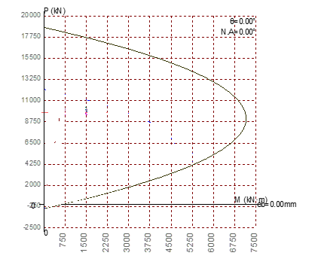

* + 1. Direction Y

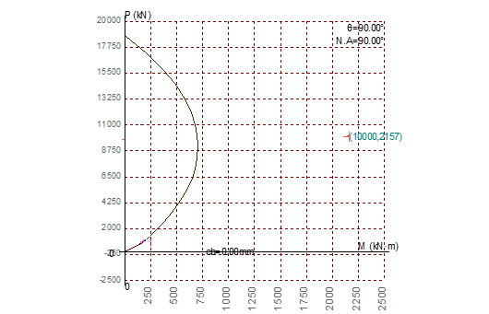

* 1. Shear Capacity

|  |  |  |  |
| --- | --- | --- | --- |
|  |  |  | **Remark** |
| 100.00kN | 488kN | OK(0.205) |  |

* 1. Rebar Spacing

|  |  |  |  |
| --- | --- | --- | --- |
| **Check Items** | **Vertical** | **Horizontal** | **Remark** |
|  | 0.00250 | 0.00250 |  |
| **ρ** | 0.21290 | 0.05462 |  |
|  | OK(0.0117) | OK(0.0458) |  |
|  | 330 | 200 |  |
| **s (mm)** | 100 | 150 |  |
|  | OK(0.303) | OK(0.750) |  |